Hastings Public Schools
INDEPENDENT SCHOOL DISTRICT 200
1000 11TH STREET WEST
HASTINGS, MN 55033
BRIDGE TO SUCCESS Phone (651) 480-7000

Parent Name: ________________________________________

Dear Parent/Guardian of: ______________________________
Welcome to Infinite Campus PARENT Portal!
Infinite Campus is a district-wide student information system designed to manage attendance, grades, schedules, assessments and other information about our students. Parents/guardians of students in grades 5-12 have access to Campus Portal which is a confidential and secure website that allows parents/guardians to log in and view their child's progress in school. There is also an app available for both iOS and Android devices.
Logging into the Campus Portal will allow you to view the following real-time information about your child:

- Demographics | - Grades | - Report Cards
- Schedules | - Attendance | - District and School Notices
- Assignments

In addition to viewing information through your portal account, you may also use the portal to update your phone numbers and email addresses.

Instructions for logging into your parent portal account are located on the back of this letter.
Please note that this parent account is intended to be used by parents/guardians and will allow you to access information on all students in your household. All students in grades 5-12 will also receive their own personal student accounts which will allow them to access only their own information. We advocate that students use their personal student accounts rather than a family/parent account to ensure data privacy.

If you have additional questions regarding Infinite Campus or Campus Portal, please contact your child’s school.

For the opportunity to access Campus Portal, every parent/guardian is asked to act in a responsible, ethical and legal manner. By accessing Campus Portal, parents agree to adhere to the following guidelines:

1. Not share his/her password with others.
2. Not attempt to alter, harm or destroy data.
3. Not use Campus Portal for any illegal activity, including violation of Data Privacy laws.
4. Not access data or any account owned by another parent.
5. Will notify ISD 200 immediately if s/he identifies a security problem with Campus Portal.
6. Understands that s/he be denied access if s/he is identified as a security risk to Campus Portal.

How to create your PARENT Portal Account
Click on the Parents link at the top of the building or District #200 webpage and then click on the Campus Portal Login link located on the Parents page.
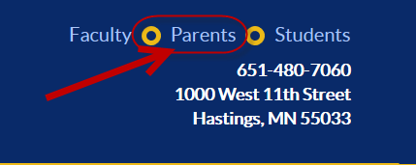 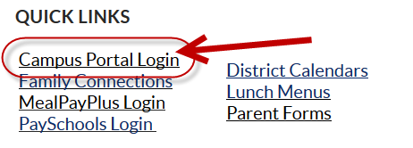

- From the Portal login page, click on the option that says “If you have been assigned a Campus Portal Activation Key click here”
- Enter your personalized 32 digit Activation key and click on the Submit button. Your activation is:
___________________________________________
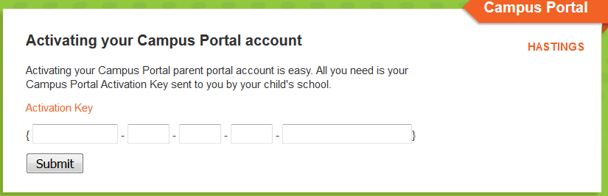
- You are now ready to create your Campus Portal account.
* Enter a UserName – Usernames may not include numbers and are case sensitive.
* Enter a Password – Passwords must include alpha and numerical characters, and be at least 8
characters in length. Passwords are case sensitive.
* Enter the password again and then click on Create Account.
* Please record username and password in a secure and private location.

- After selecting Create Account, you will see that your Campus Portal account was created successfully. Select Click here and you will be brought back to the Campus Portal Login page.
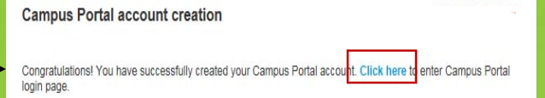

- The next time you log in to Campus Portal, the system will prompt you to set up an account security email. Setting up your account security email will allow you to recover your username or reset your password in the future if you ever forget them. You will need to enter and save your email address before continuing into the system. You will only need to complete this step the first time you log in.

If you need help, please visit our Campus Portal Help page on the Parents webpage or contact your child’s school.

